Home recording microphones

Sennheiser’s MK 4 and e 614 microphones deliver first-class guitar sound

Wedemark, 3 April 2020 – Making the best of time at home can also be a golden opportunity to create something really special. If you’ve always dreamt of recording your music, there’s no reason to hold back. It’s time to dust off that guitar, tighten the strings, play your favorite song and start recording. You’ll be amazed at what you can create...!

To best capture your musical ideas for sharing with others, the first link in any audio signal chain is particularly important: that means having a microphone that is up to the task. A good mic can precisely capture sound with all its nuances – the process by which the sound hitting the diaphragm is converted into electric energy is crucial for the result. After all, everything that has not been recorded cannot be added later – even with the latest digital tools.

Dust off your guitar, tighten the strings and play your favorite song | 

The Sennheiser MK 4 allows audio recordings with professional sound at home: With its cardioid pick-up pattern, this large-diaphragm true condenser microphone is ideal for recording vocals and acoustic instruments. Audio professionals appreciate the Sennheiser MK 4 for its powerful, natural and direct sound that brings out the best in acoustic guitars. Its condenser capsule is internally shock-mounted, so it will not transmit any handling or structure-borne noise. The Sennheiser MK 4 is “Made in Germany” to the highest quality standards and comes complete with a microphone clamp and pouch.

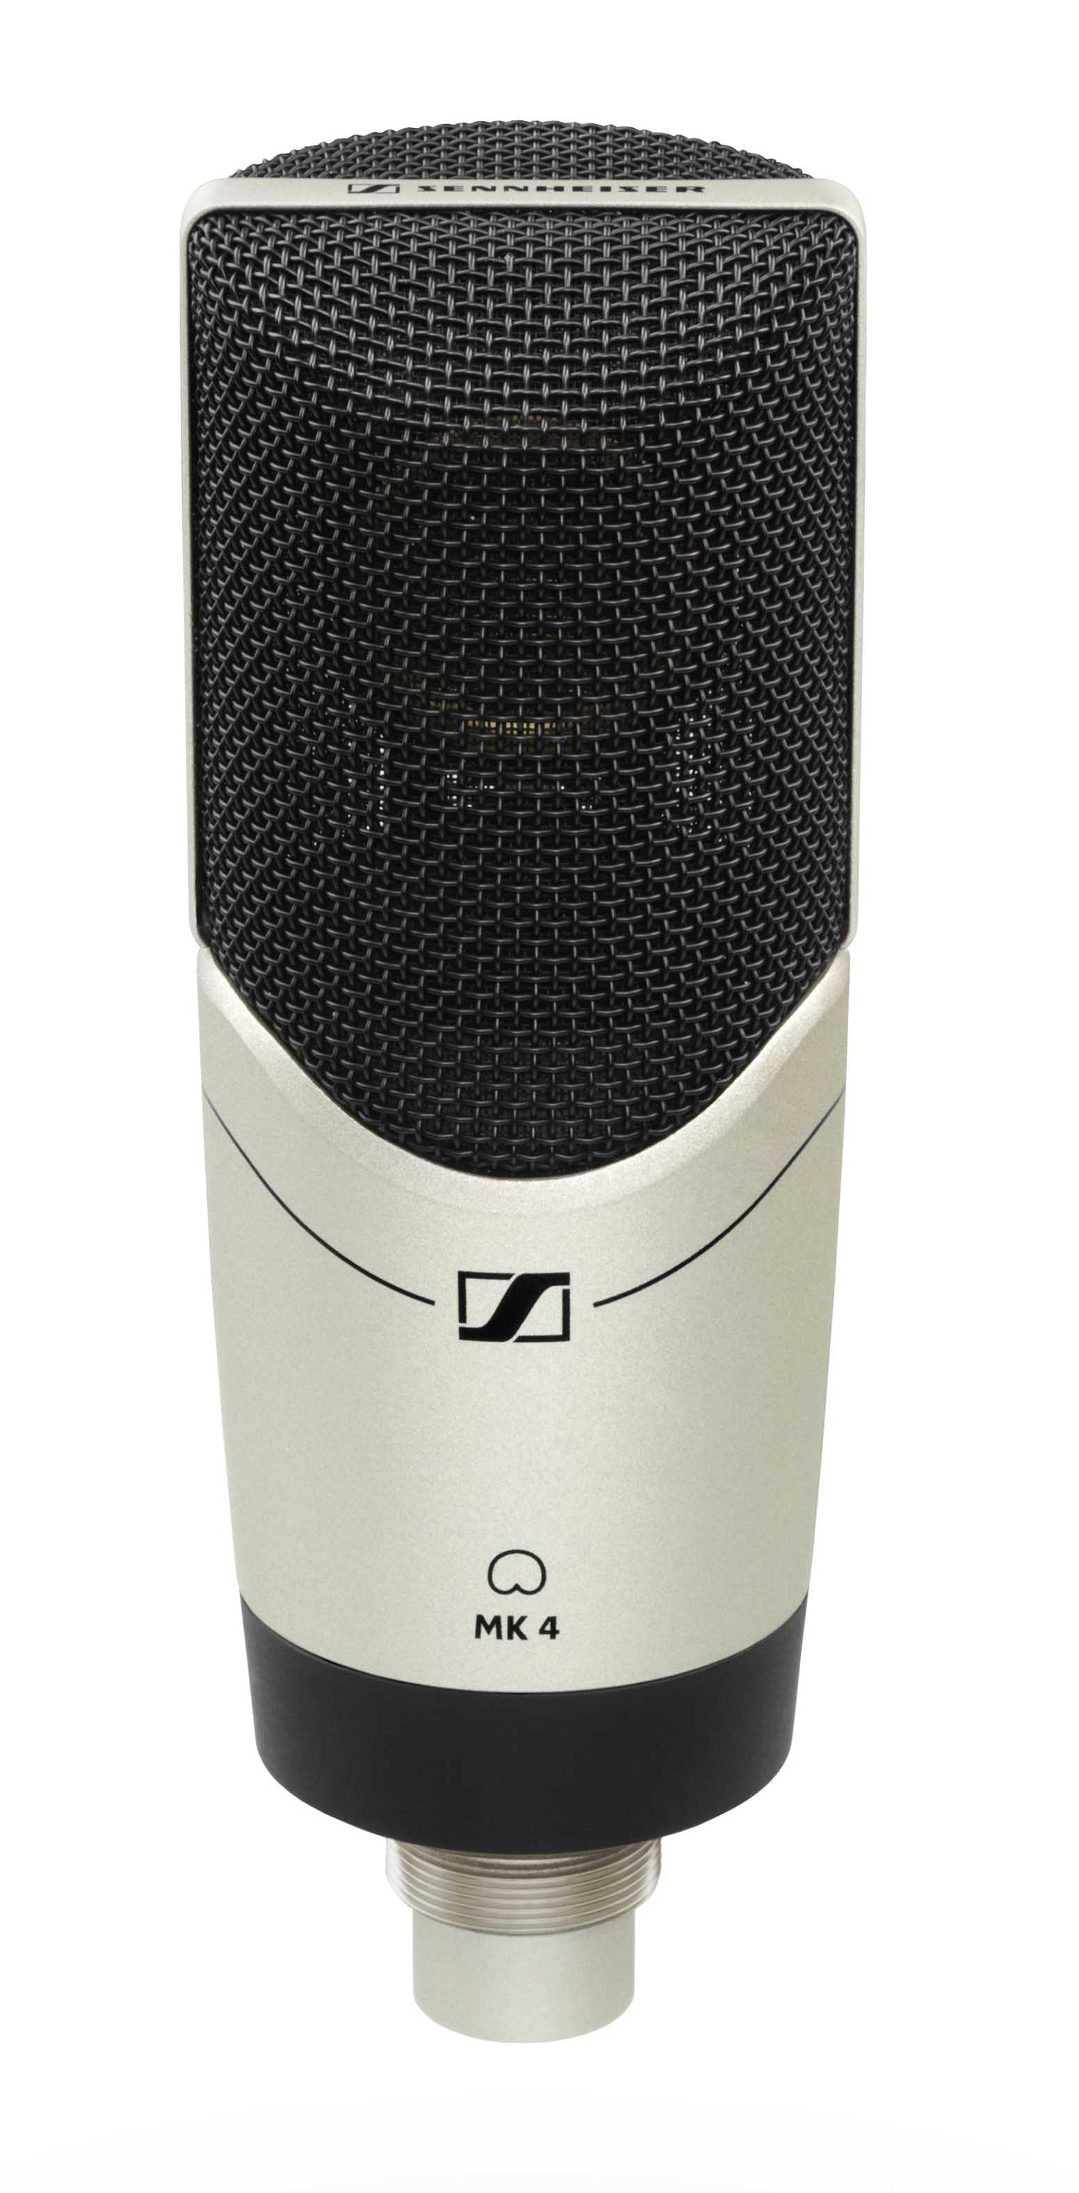 | Ideal for recording vocals, piano and guitar: the Sennheiser MK 4

An alternative to the MK 4 is the e 614 small-diaphragm microphone: This super-cardioid electret condenser microphone can be used for various applications and is characterized by a high maximum sound pressure level and fast transient response. For this reason, its sound is dynamic and silky-brilliant – especially with a percussive playing style, transients are perfectly reproduced. For every guitarist who appreciates fine-silvery overtone structures, the Sennheiser e 614 is the perfect choice.

Music recordings captured with the Sennheiser e 614  impress with a dynamic and silky-brilliant sound | 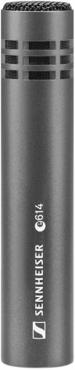

Both the Sennheiser MK 4 and e 614 not only stand out for their first-class sound and build quality, but also because of their attractive price-performance ratio. Both models can be ordered with free shipping from the Sennheiser online shop. To learn more, or order your own mic today, please visit the Sennheiser website at www.sennheiser.com.

The images accompanying this press release can be downloaded at https://sennheiser-brandzone.com/c/181/1jbRXeAR .

About Sennheiser
Founded in 1945, Sennheiser is celebrating its 75th anniversary this year. Shaping the future of audio and creating unique sound experiences for customers – this aim unites Sennheiser employees and partners worldwide. The independent family company, which is managed in the third generation by Dr. Andreas Sennheiser and Daniel Sennheiser, is today one of the world’s leading manufacturers of headphones, loudspeakers, microphones and wireless transmission systems. In 2018, the Sennheiser Group generated turnover totaling €710.7 million. www.sennheiser.com

Global Press Contact

Stephanie Schmidt
Stephanie.schmidt@sennheiser.com
+49 (5130) 600 – 1275

